D. Difference between :
1. Ray and beam
Ray | Beam
It is a single path of light. | It is composed of multiple rays.
It travels in a straight line. | It travels in a specific direction .
E.g: A ray from the Sun passing through a small hole | E.g:Sunlight entering through a window, forming a visible shaft.

2. Umbra and penumbra
Umbra | Penumbra
No light reaches this region. | Some light reaches this region.
It occurs due to total obstruction of light. | It occurs due to partial obstruction of light
It is completely dark. | It had faint or lighter shadow.

E. Give reasons:
a. Opaque object produces shadow.
- because they totally block the light fro the source.
b. Pin hole camera produces inverted image.
- because light rays travel in straight lines and cross at the pinhole.
c. Direction and size of a shadow can provide the time.
- because of change in position of sun which help to indicate the time of day.
G. Short answer type questions.
1. What does rectilinear propagation of light mean? In which device do we use this principle?
- Rectilinear propagation of light means the property of light that states light travels in a straight line.
-we can use this principle in pinhole camera.
2. How can we see the object around us?
- We can see objects around us because light from a source reflects the objects and enters our eyes which allows the brain to form an image of the object.
3. What is beam? What difference is the beam if the light coming from
a) a distant source b) a point source
- A beam is a bundle of light rays traveling together in the same direction.
a) Distant source: The beam is almost parallel (like sunlight).
b) Point source: The beam spreads out as it moves away from the source.
4. How does sundial work?
-A sundial works by using the shadow of a stick cast by the sun.
5. What is shadow? What are the things necessary to form a shadow.
- Shadow is a dark area formed by an object when it blocks the light.
-The things necessary to form a shadow are:
1.Source of light
2. An opaque object
3. A surface
H. Long answer type questions .
1. What is light? Why is light important to us?
Light is a form of energy that helps us to see things around us. It travels in a straight line.
Light is important to us because it helps us to see objects, makes our surroundings bright, and helps plants to make food through photosynthesis.
2.Show an experiment that proves the rectilinear propagation of light.
Take three cardboards and make a small hole in the center of each. Arrange them in a straight line and place a lighted candle in front of the first cardboard. When all three holes are in one straight line, we can see the flame through them.
If one cardboard is moved aside, the flame is no longer visible.
This shows that light travels in a straight line (rectilinear propagation of light).

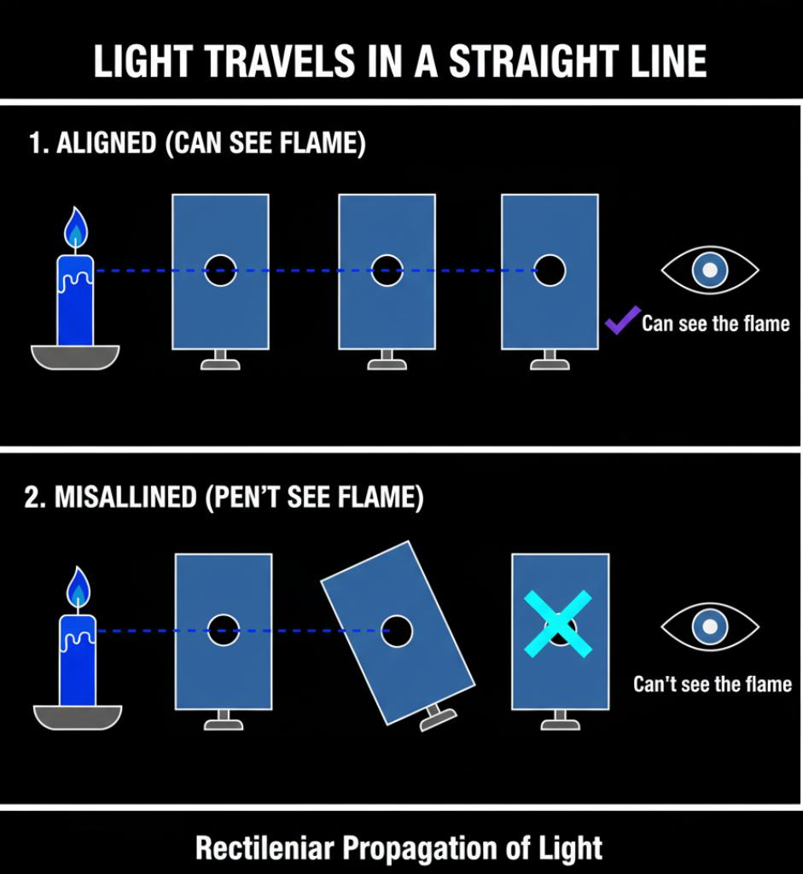

3. Can we make a camera without lens and mirror? What is the name of such a camera?
Yes, we can make a camera without a lens and mirror.
Such a camera is called a pinhole camera.
4. Give the process of constructing pinhole camera.
- Give the process of constructing a pinhole camera.
- Take an empty box or can and make one side open.
- Cover one end with black paper and make a small pinhole at its center.
- On the opposite side, fix a white tracing paper or butter paper to act as a screen.
- Your pinhole camera is ready.
When you face the pinhole toward a bright object, an inverted image of the object appears on the screen.
5.What is shadow? How can we increase and decrease the size of a shadow?
A shadow is a dark area formed when an object blocks the path of light.
The shadow becomes bigger when the object is closer to the light source.
The shadow becomes smaller when the object is farther from the light source.
6.How is image formed in a pinhole camera? Light travels in rectilinear path but the image formed by pinhole camera is inverted, how is this possible?
In a pinhole camera, light from the top of the object passes through the pinhole and falls on the bottom part of the screen, while light from the bottom of the object falls on the top of the screen. Since light travels in straight lines and crosses at the pinhole, the image formed on the screen becomes inverted (upside down).

